# Exercise: Position & Float

Problems for exercises and homework for the ["HTML and CSS" course @ SoftUni](https://softuni.bg/trainings/2983/html-and-css-may-2020). Submit your solutions in the SoftUni Judge system at <https://judge.softuni.bg/Contests/#!/List/ByCategory/134/HTML-and-CSS-Exercises>.

# Article with Quotes and Media

You can take an old solution of this task and modify them to match the requirements. Create a web page like the following:

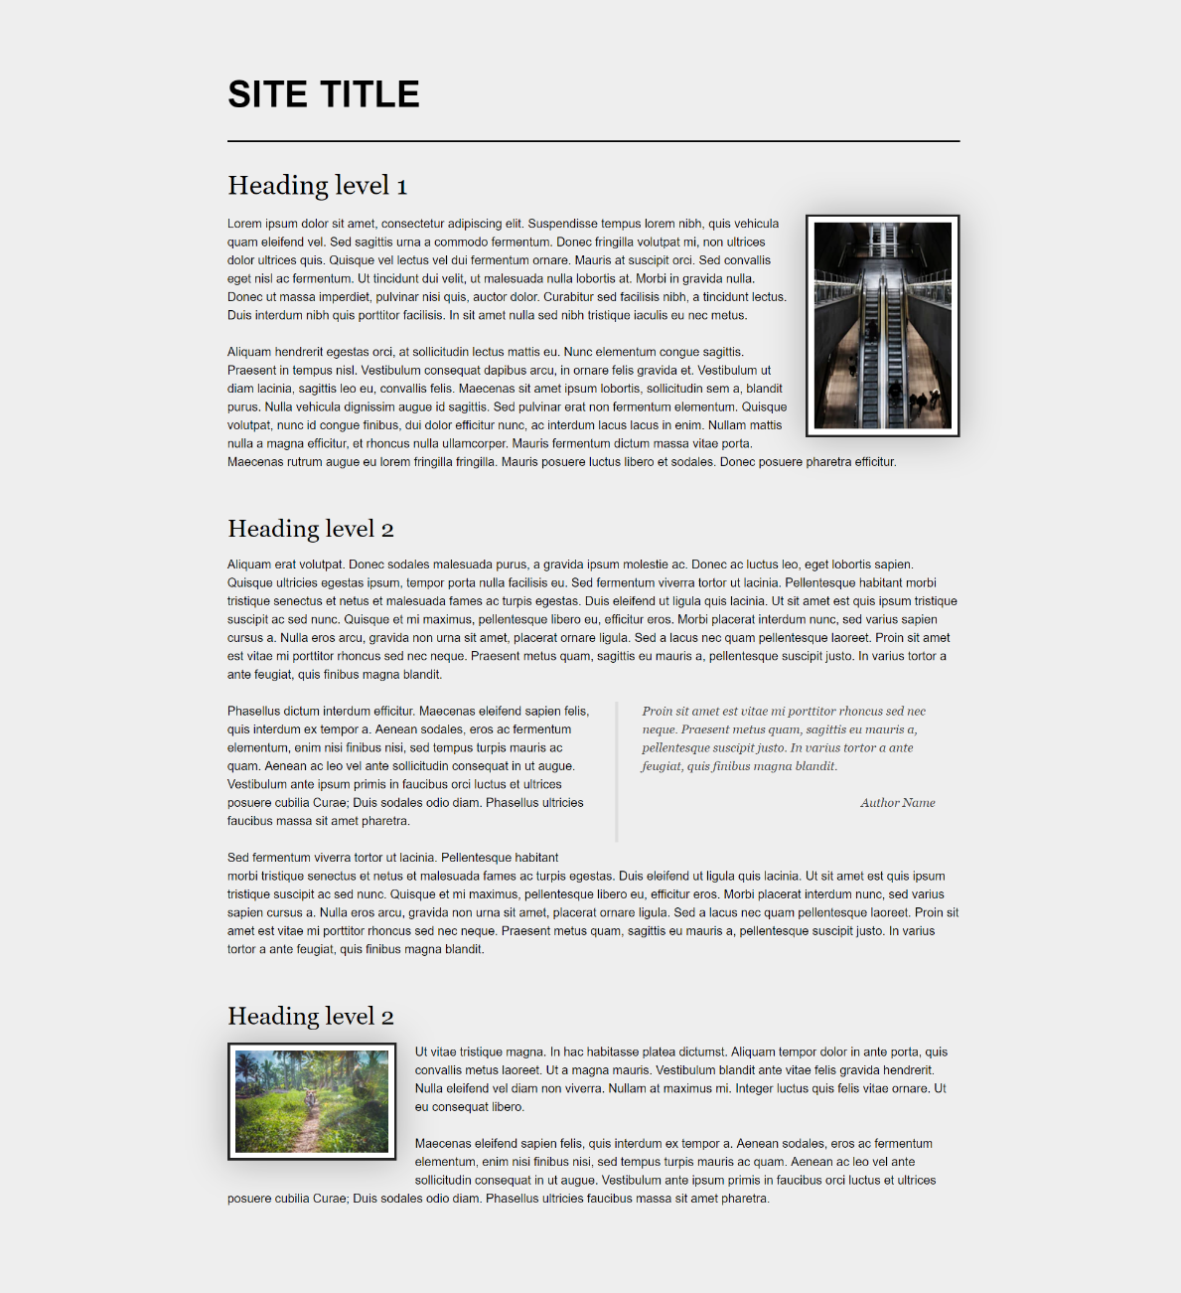

### Constraints

* Divide your content into header and main tags
* The entire page font should have the following properties:
  + Size - 16px
  + Line height - 1.5
  + Font family - Helvetica, sans-serif
* Add class site-title to the paragraph in the header (p.site-title)
  + Change the display property to inline-block
  + Set the font weight to bold
* Transform the text to uppercase

## Blog Layout - Float

Create a web page like the following:

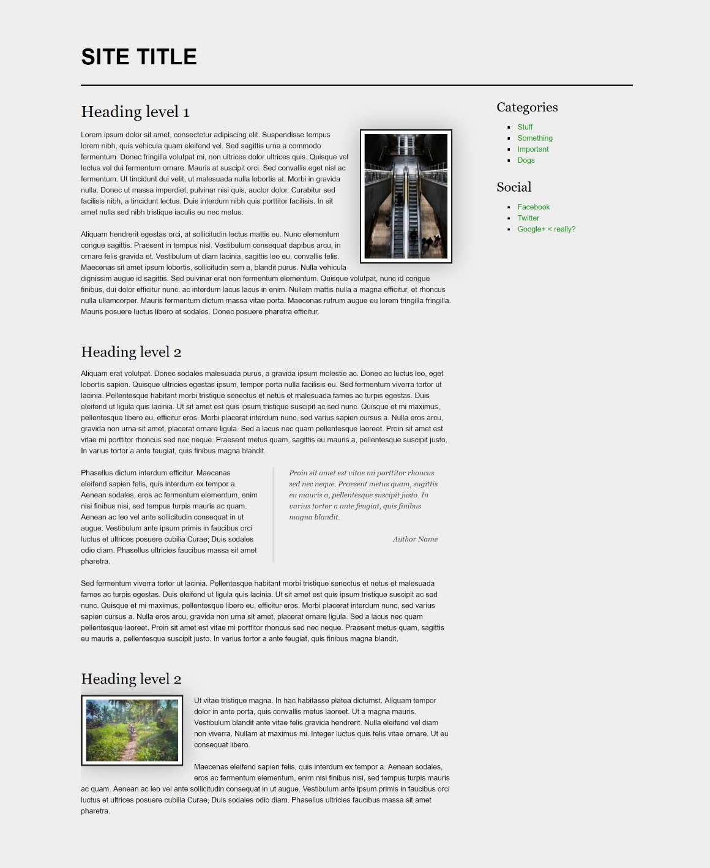

### Constraints

* Change the document **title** to "**Blog Layout - Float"**
* Divide your content into header, main and aside tags
  + Create a paragraph inside the header for the site title
  + Create an article inside the main
  + Create two sections inside the aside
    - The sections should have a h3 heading and a navigation - nav with ul, li and a elements
* Use rgb(238, 238, 238) for body background
* Use rgb(255, 255, 255) for image background and rgba(0, 0, 0, 0.25) for image box shadow
* Use font family Georgia, serif for the blockquote
* Use font family Georgia, serif with size 1em/1.2 for the headings
* Use float property to position the first image on the right
* Use float property to position the second image on the left

## Position Playground

Create a web page like the following:

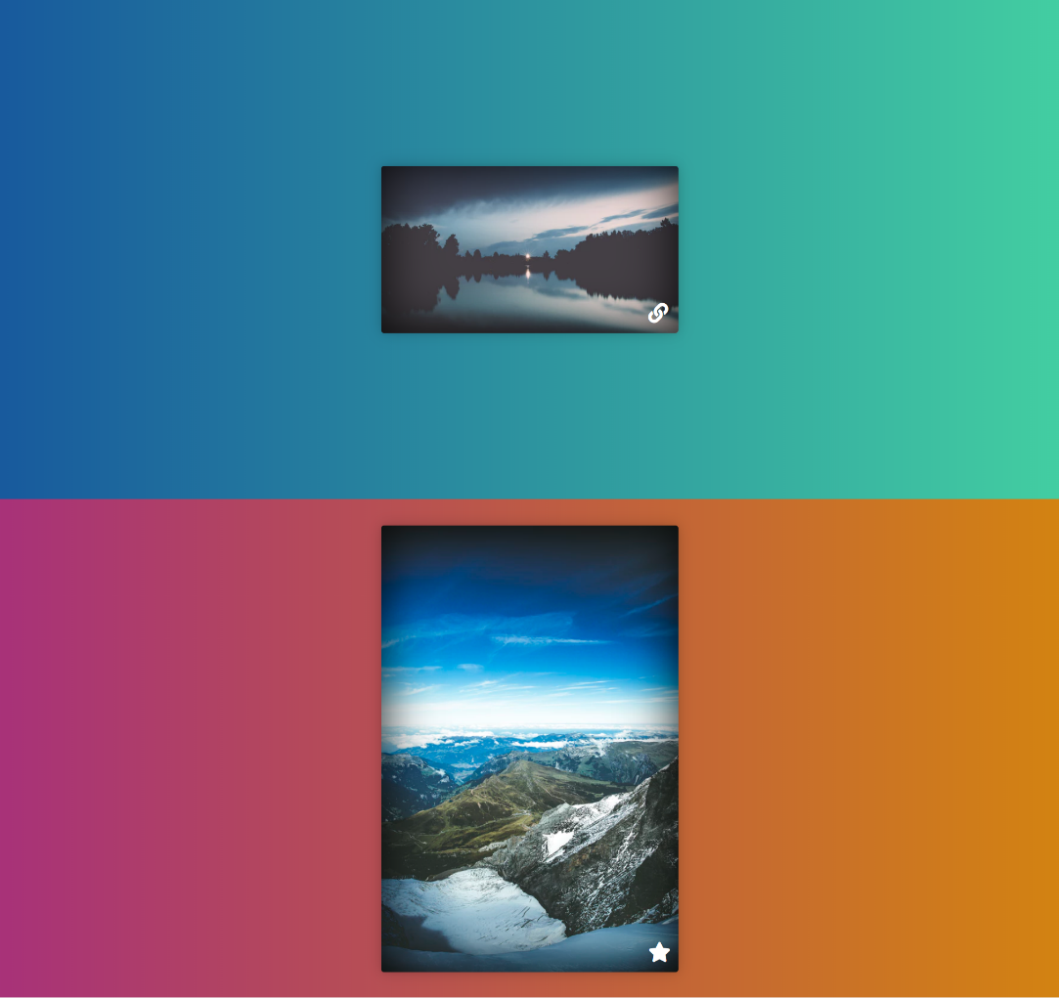

### Constraints

* Change the document title to "**Positioning Playground**"
* Import [Font Awesome](https://fontawesome.com/) into your **CSS** file
* Add two container units **(**divs**)** with class viewport inside the body
  + Inside each one add section with class card *(*section.card*)*
    - Change the display property to block
    - Try to center the section with position property absolute

## Center Position and Transform

Create a web page like the following:

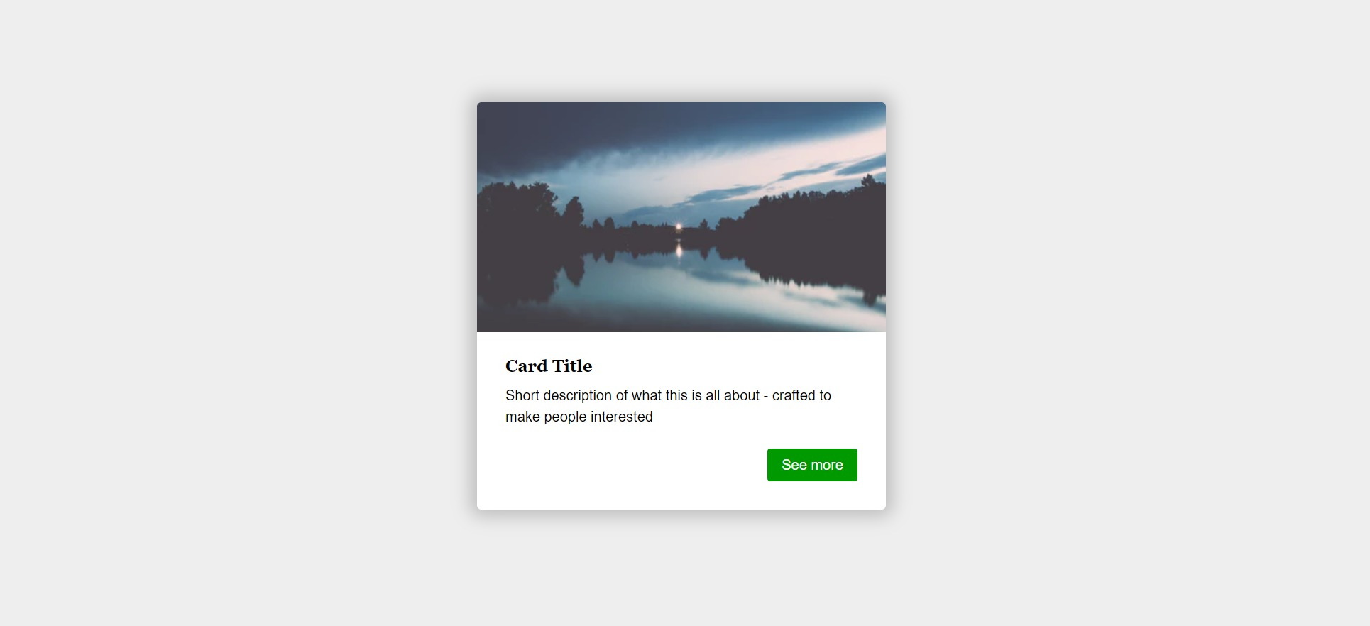

### Constraints

* Change the document title to "**Center Position and Transform**"
* Create section with two divs
  + Look the screenshot for the inner items
* Use rgb(238, 238, 238) for body background
* Use rgb(255, 255, 255) for card background
* Use rgb(0, 153, 0) for card button background
* Use font Georgia, serif with size 1em/1.2 for the headings
* Set the image position property to absolute

## Floating Images and Quotes

Create a web page like the following:

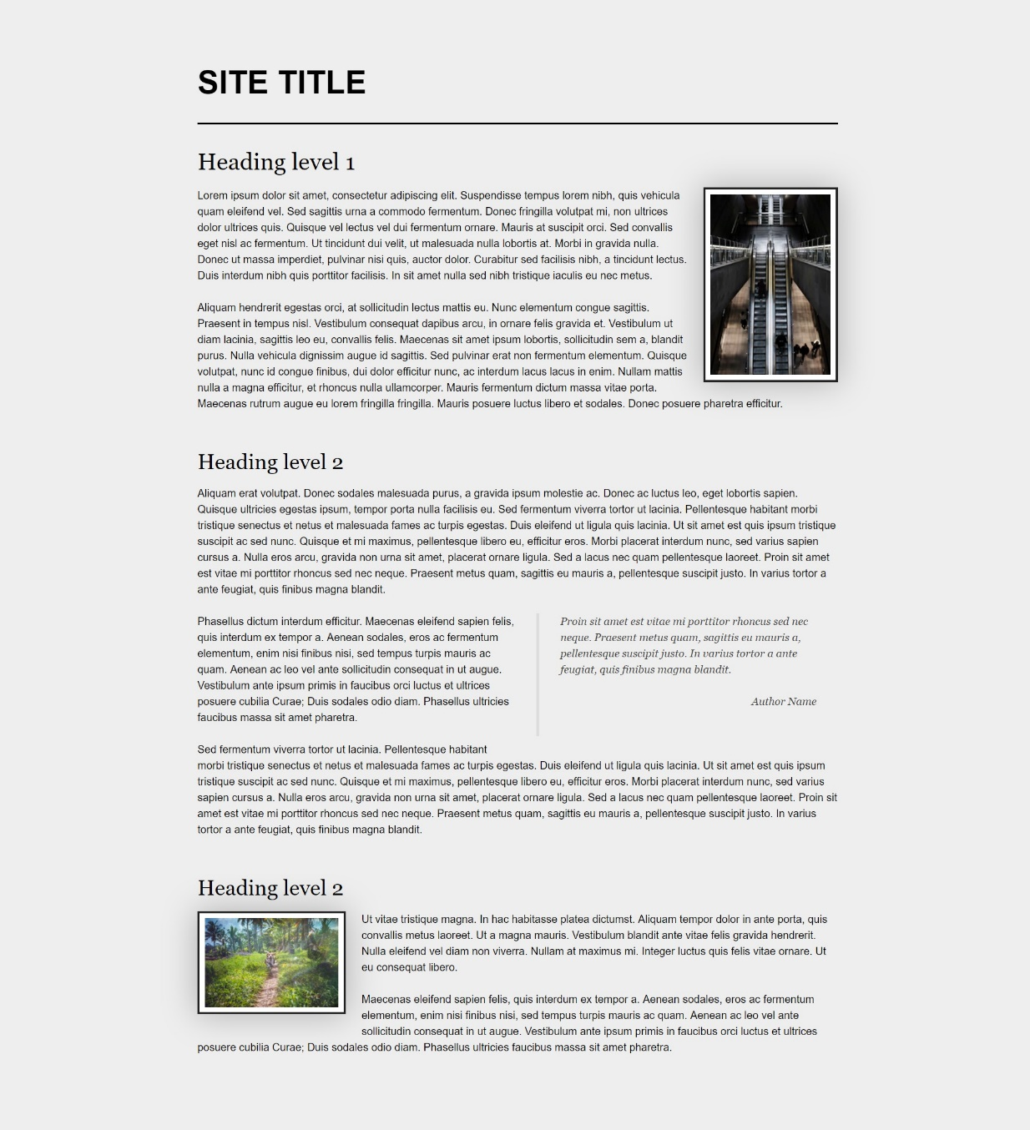

### Constraints

* Change the document title to "**Floating Images and Quotes**"
* Create a header with h1 inside
* Add an article and look the screenshot for some insight for the other items inside
* Use color - rgb(238, 238, 238) for body background
* Use color - rgb(255, 255, 255) for image background and rgba(0, 0, 0, 0.25) for image box shadow
* Use font family Georgia, serif for the blockquote and headings

## Navigation Float

Create a web page like the following:

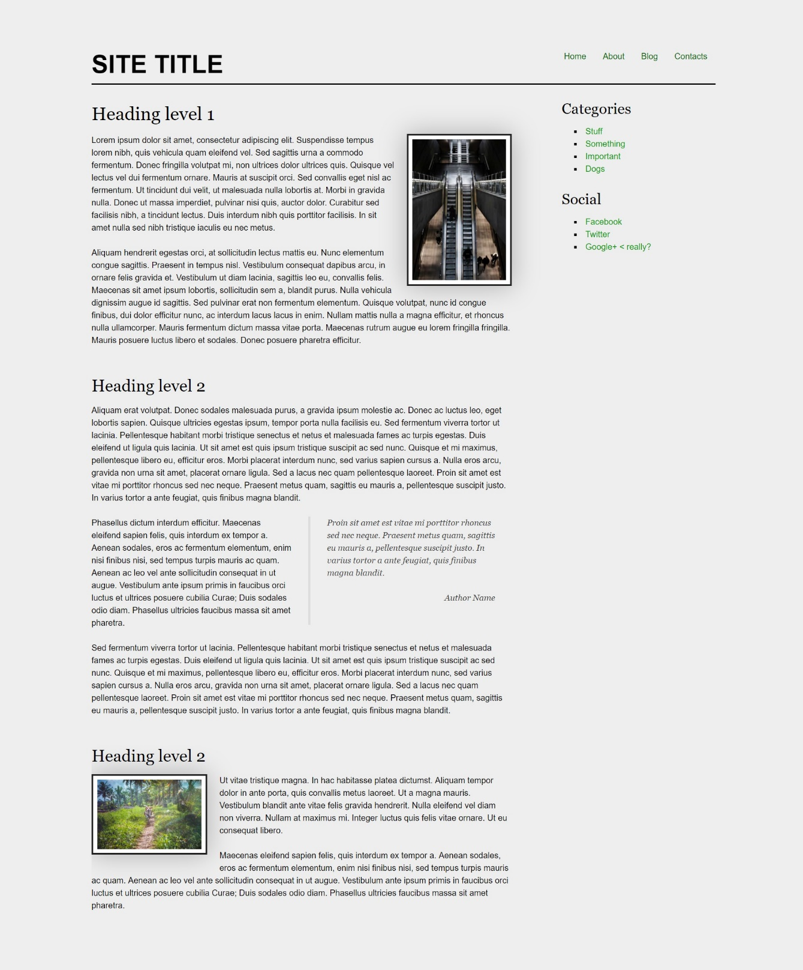

### Constraints

* Change the document title to "**Navigation - Float**"
* Create a header with a p for as title
  + Inside the header add a nav with a ul and 4 li elements
* Create a main, which contains an article with a header and h1 heading
  + Add a section inside the article
* Create an aside element with two sections inside
  + The sections should have a h3 heading and a navigation - nav with ul, li and a elements
* Use rgb(0, 102, 0) for the anchors
* Use rgb(238, 238, 238) for body background
* Use rgb(255, 255, 255) for image background and rgba(0, 0, 0, 0.25) for image box shadow
* Use font Georgia, serif for the blockquote
* Use font Georgia, serif with size 1em/1.2 for the headings

## Social Media Icons

Create a web page like the following:



### Constraints

* Change the document title to "**Social Media Icons**"
* All you need for your HTML are ul, li and a tags
* Use FontAwesome to add social icons
* Change the ul display property to inline-block
* Remove list items default style
* Each a tag must have border-radius: 50%;
* Check the provided screenshots to see the hover effects